Simran Shilky

9918103027

F1

**Assignment 4 Solution**

**Practice Question Solutions**

**Q1)#Calculate the frequency of occurrence of each character/integer in that list**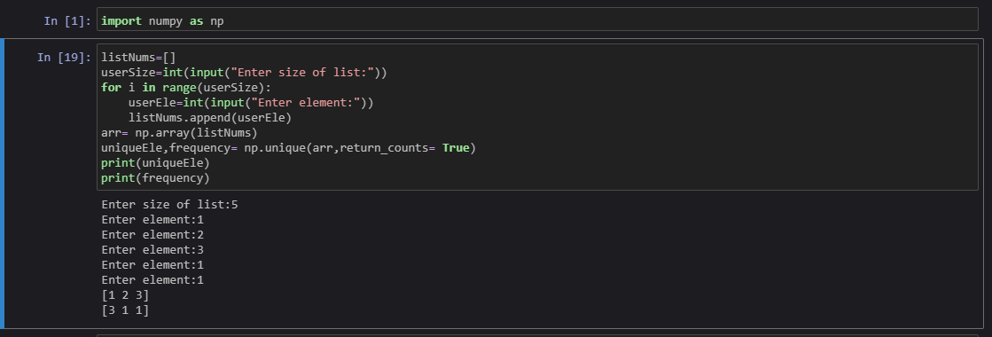

**Q2)#Take a binary input from the user and segregate all 1's to the left and 0's to the right sides.**

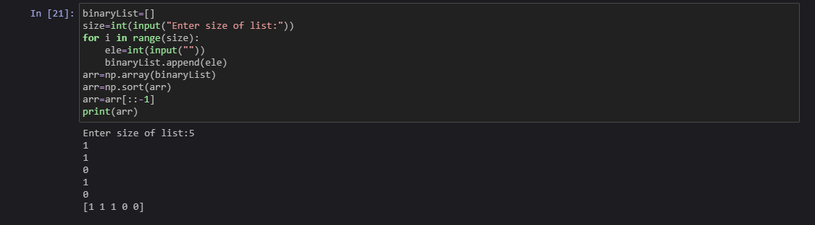

**Q3)# To remove the nth index character from a nonempty string**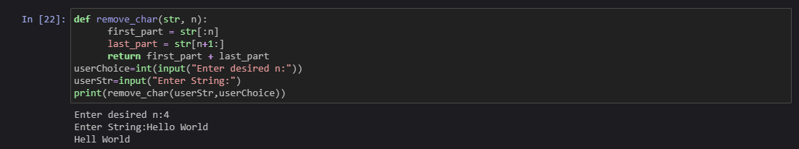

**Q4)#To test whether each element of a 1-D array is also present in a second array.   
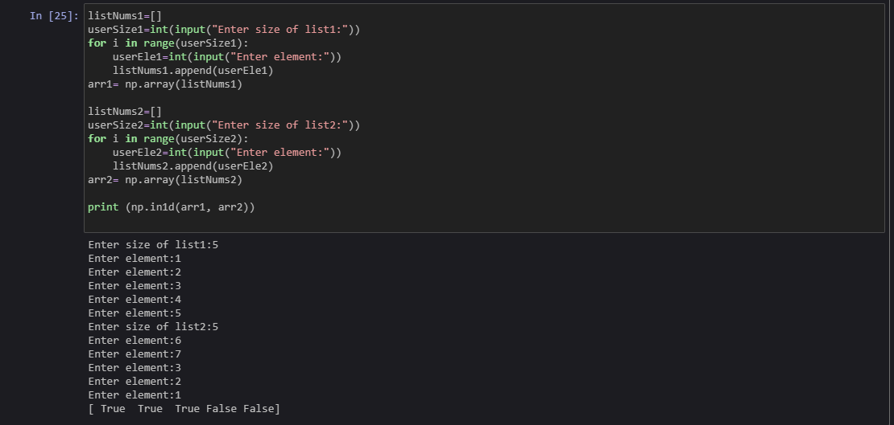**

**Q5)# To find the set exclusive-or of two arrays**